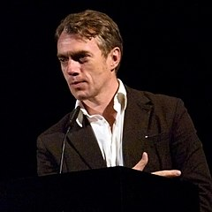

NEO RAUCH from Germany
(born on 18. April 1960 in Leipzig, Germany)

KNOWN AND FAMOUS…..
- for his idea of sampling: elements of art history, paraphrases of surrealism and metaphors of daily work life are combined.
- for having experienced the regime in the DDR, former Eastern Germany, as a teenager.
LIFE…
- Only four weeks after his birth Neo Rauch´s young parents died in a train accident. He grew up with his grandparents who were still very young for being grandparents (not 40 yet). They looked after him and his well-being in detail.
- After completing his A-levels he studied art painting at the Hochschule für Grafik und Buchkunst in Leipzig from 1981 till 1990.
- First he became an assistent of a famous German artist in Leipzig and then he started teaching art himself at the university. From 2009 till 2014 he worked as a professor in honour at the university.
- Neo Rauch is married to an artist called Rosa Loy. They have a son who is already an adult. The couple lives close to Leipzig.
- The city of Leipzig is home for Neo Rauch. That is where he gets the best and his constant inspiration.

STYLE…
- Paintings are bright and colourful.
- Fihures are shown in overlapping spaces and time levels.
- His style resembles a socialistic realism, but there are also elements of pop art and comic.
- Mostly his works resemble surrealism and an be described as magical realism. His ideas often seem of dream like.
- Rauchs painzings are shown in the Metropolitan Museum of Art in New York and in the Museum der bildenden Künste in Leipzig.

CURIOSITY…
- Rauch´s paintings are popular with Hollywood stars. Brad Pitt likes his paintings and has already bought some.
- Neo Rauch is sometimes called the “Robbie Williams of the art world“. Is it because of his outward appearance or the hype created about his personalty?
- He needs bodyguards when he shows up and sometimes girls scream and faint when they see him.
- His painting „“Platz“ was sold for 1.641.085 Dollar.
MASTERPIECES….
- Tal, 1999, 200cm x 250 cm, oil on canvas (private collection)

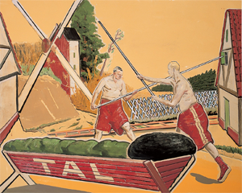

- Fastnacht, 2010, 2,5 m x 3 m, oil on canvas, (Museum der bildenden Künste Leipzig)
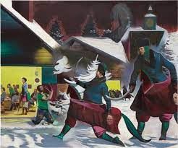
- Die Kontrolle, 2010, 300 cm x 420 cm, oil on canvas, private collection
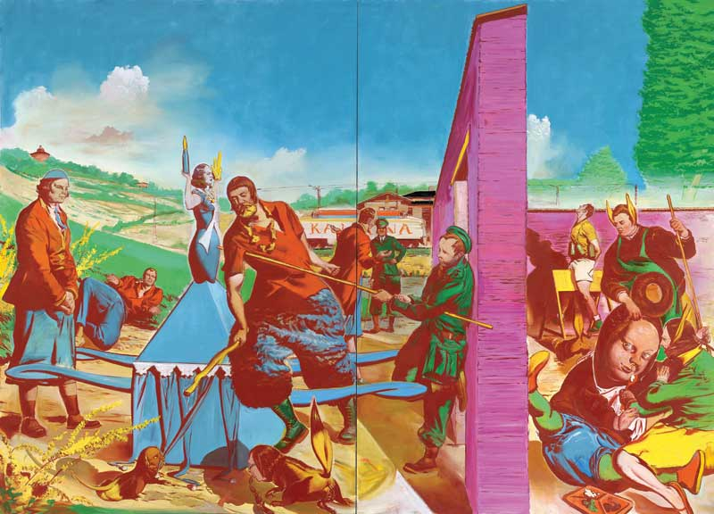

- Die Fuge, 2007, oil on canvas

