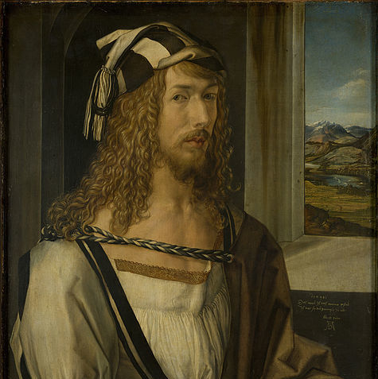

Albrecht Dürer from Germany
(born in 1471 in Nürnberg, Germany, died in 1528 in Nürnberg, Germany)

KNOWN AND FAMOUS…..
- for establishing the printing technique with wooden carvings and copper printing
- for already being a genius at the age of 13
- for his “praying hands”

LIFE…
- Dürer was born in Nürnberg, Bavaria, Germany.
- His dad was a goldsmith. His dad wanted him to become a goldsmith, too. So his dad started to teach him when he finished school at the age of 13.
- But it was quite obvious that Albrecht was very good at drawing. See below the self-portrait he did when he was only 13.

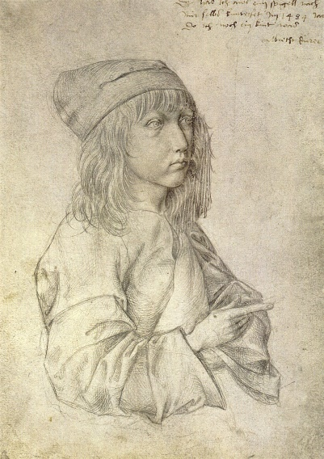
- That´s why he was allowed to do an apprenticeship with a famous artist in Nürnberg.
- Albrecht did several journeys within Europe to learn more about painting.
- He married at the age of 23. His wife Agnes Frey and Albrecht had no children.
- When he was 26 he opened up his own studio.
- He did not only draw and paint, but made use of new techniques common for printing: With a knife he created carvings on wooden boards so called “woodcuts“. He did the same on copper plates, then called “copper engravings“. Finally it was possible to create as many prints as one wished to have. So one masterpiece could be printed and sold several times.
- As an experienced artist he travelled to Venice, Italy and The Netherlands.
- Dürer died in 1528. No one really knows whether he was seriously ill before passing away. But what we do know is that he left his wife a lot of money.

STYLE…
- Dürer was and remains the most famous artist of the northern renaissance. He was able to combine the very detailled northern style with the ideals of the Italian renaissance.
- His graphics and his graphic style are world-famous.
CURIOSITY…
- His graphics are most famous today, however he made a fortune at his time with his painting of portraits and religious designs.
- His house, the one in which he lived, is a museum in Nürnberg today and can be visited.

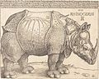
"Rhinozeros", 1515
Dürer painted this detailled rhino, even though he had never seen one. He just read
descriptions about this animal. Amazing.
MASTERPIECES….
- Praying hands, 1508, 29 cm x 19 cm, ink on paper (Albertina, Vienna)

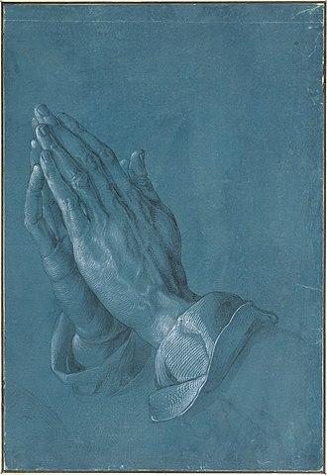
- Feldhase, 1502, 25 cm x 23 cm, watercolour (Albertina, Vienna)

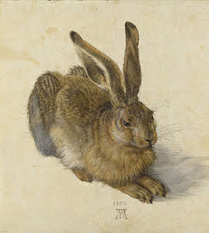

- Der heilige Hieronymus im Gehäus, 1514, copper engraving, (Rijksmuseum, Amsterdam)

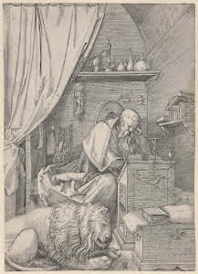
- Portrait of Dürer´s mother (shortly before her death), charcoal drawing, 1514 ( Kupferstichkabinett, Berlin)

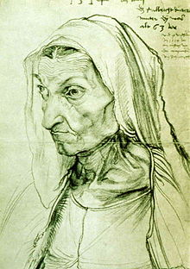

Christus unter den Schriftgelehrten, painting, about 1600, 123 cm × 141 cm,
(Kunsthistorisches Museum, Vienna)

