Julije Klović- Julio Clovio de Croatia
(born in 1498 in Grižane, Croatia, died in 1578 in Roma)

KNOWN AND FAMOUS…..
- the greatest miniaturist of the Renaissance period
- his nickname, „Michelangelo of the Miniature“
- he could paint Last Supper on a fingernail

LIFE…
- Klović was born in Grižani, on the Croatian coast
- moved to Italy and entered the service of Cardinals Domenico and Grimani
- briefly moved to Hungary where he worked for King Ludovic II,
- returned to Rome and worked for Cardinal Alessandro Farnese in Rome.
- at the cardinal’s court he came into contact with the leading artists of the time – with Michelangelo, Vasari and Brueghel, who also enjoyed the cardinal’s favour. Many of his works from that period were lost.
- his grave is located near Michelangelo's Moses in the the church of S. Pietro in Vincoli, Rome, and with the inscription "Pictor de Croatia".

STYLE…
- Klović’s miniatures are drawn brilliantly, in a refined coloristic manner,
- the characters are portrayed in a decorative environment and attract attention with enigmatic expressions on their faces.

CURIOSITY…
- El Greco, who greatly appreciated Klović, portrayed him in his work "Expelling merchants from the temple" (together with figures of Rafael, Michelangelo and Tizian, appearing on the bottom left of that work).

HIS MINIATURES ARE EXHIBITED….
- The British Museum
- the Soane's Museum
- the Pierpont Morgan Library, New York
- Uffizi in Florence,
- Museo di Capodimonte in Naples,
- Biblioteca Marciana in Venice,
- Galleria Sabanda in Torino,
- Bibliothek der Albertina in Vienna,
- Louvre in Paris,
- Towneley Public Library
- Windsor Castle (Royal Library).

MASTERPIECES….
- Annunciation - Miniatures from the Officium Virginis (New York, Pierpont Morgan Library)
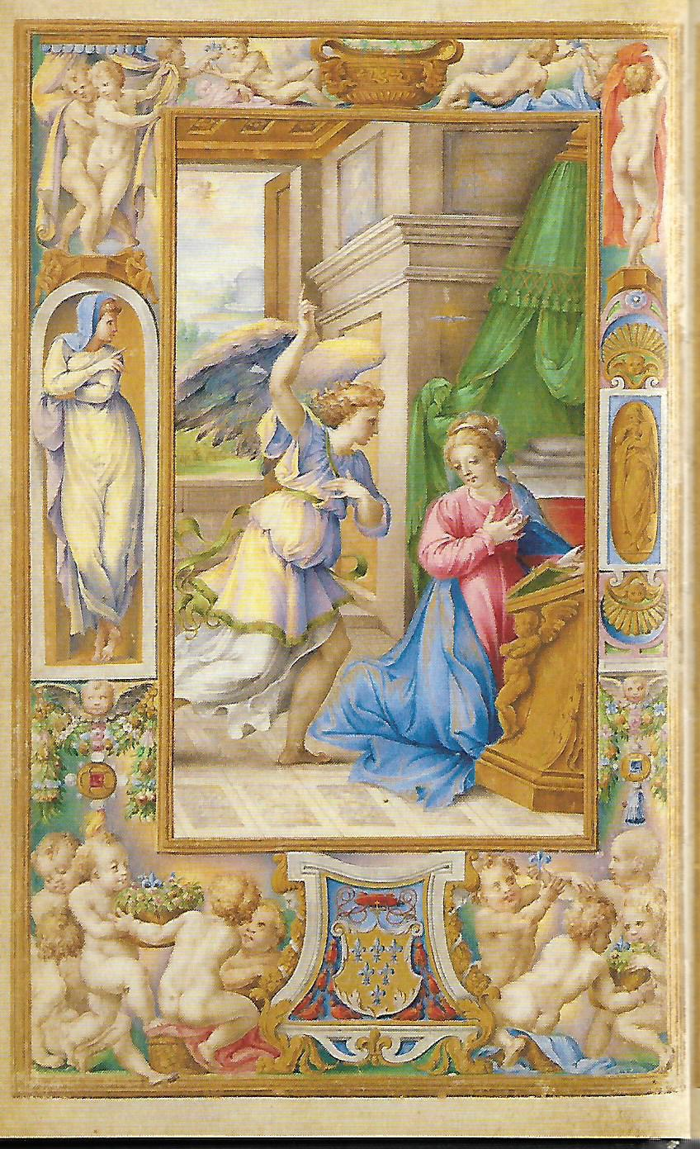 Original size: 132 x 87 mm

- Miniatures from the Officium Virginis, scenes from the Old and New Testaments: The birth of Christ, Adam and Eve in earthly paradise (New York, Pierpont Morgan Library)

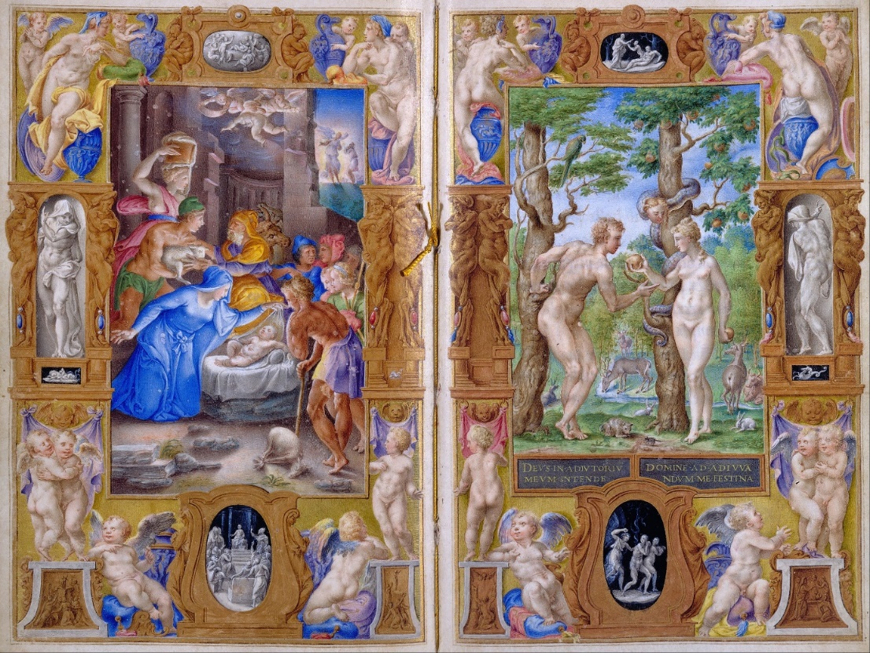

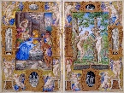 Original size: 175 x 108 mm

- The Virgin with the sleeping Jesus, St. Joseph and John the Baptist

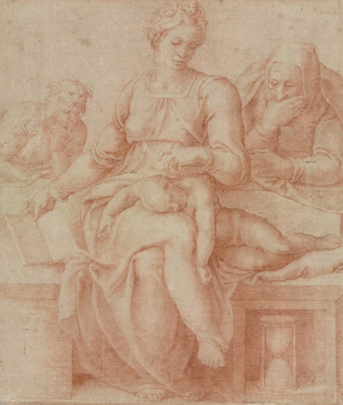 original size: 292 x 244 mm

- The abduction of Ganymede, The Royal Library, Windsor Castle, Royal Collection
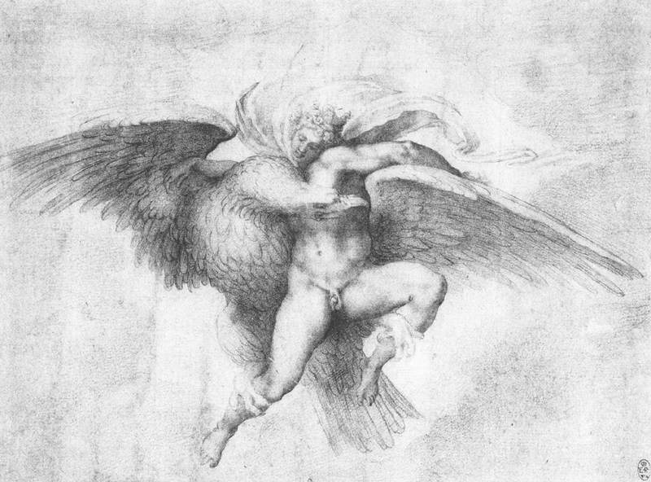 size 192 x 260 mm

- Miniature of St. John of the Cologne Gospel, parchment on paper, 1532, John Rylands University Library, Manchester
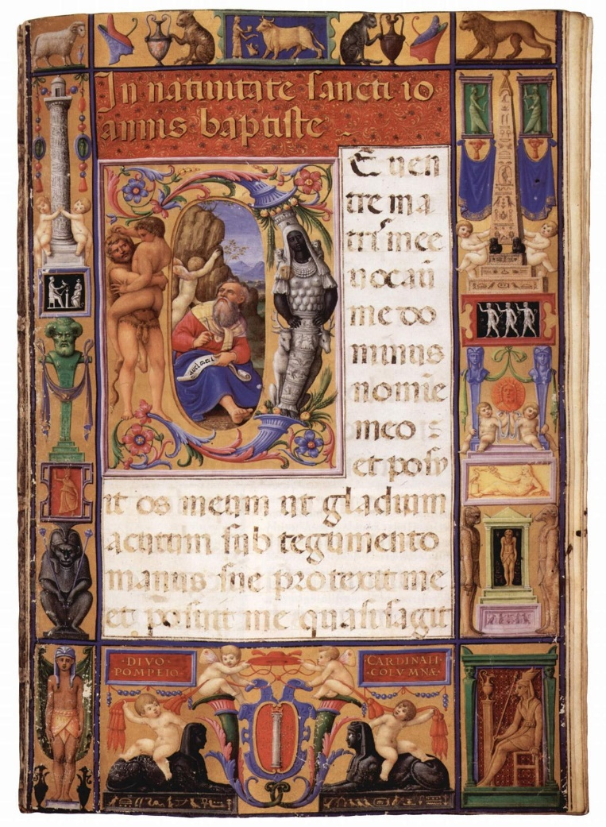 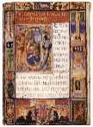 original size: 370 x 260 mm

